SOS Hub complaint process:
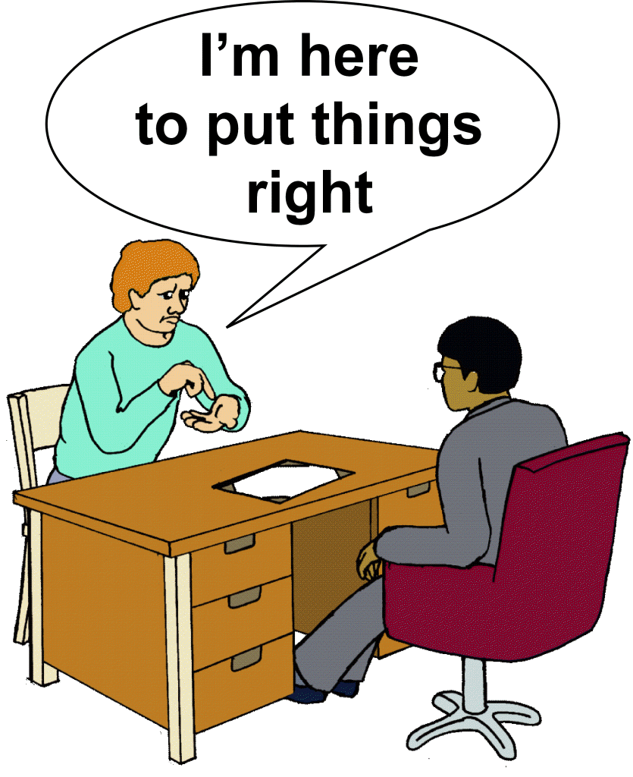 | If you are unhappy with the support you have received from SOS Hub you can make a complaint.  We will listen to your complaint and try to work out what went wrong and try to make it right.
 | To make a complaint, or raise a concern, you can either complete our contact form on the SOS Hub website, www.sosadvocacyhub.org
 | or write to us at Unit 2, 225 to 235 West Road, Westcliff on Sea, Essex, SS0 9DE
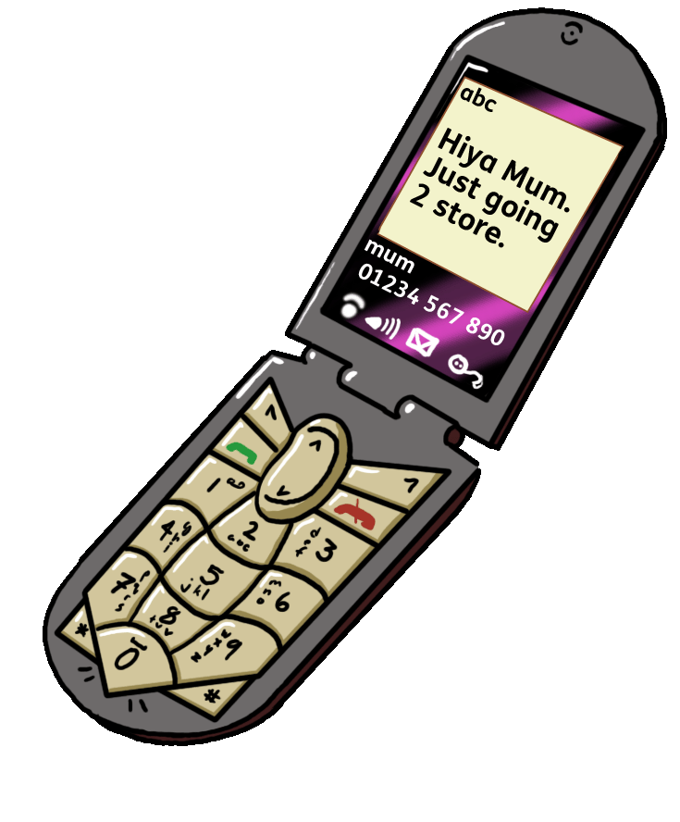 | or by telephoning us on 01702 340566
 | or by emailing us at advocacy@southessexadvocacy.org
 | If you need help to give us feedback, please let us know and we will work with you to find the best way for your voice to be heard.
 | Usually the best way for us to sort out any problems quickly is by us contacting you to discuss the problem and agree how we are going to move forward – we call this informal resolution.
 | - We will contact you within 3 working days to discuss how we can resolve things quickly
 | - We will use plain language and no jargon, and make sure you understand everything.
 | - We will treat you politely and with respect at all times, and have the right to expect you to do the same
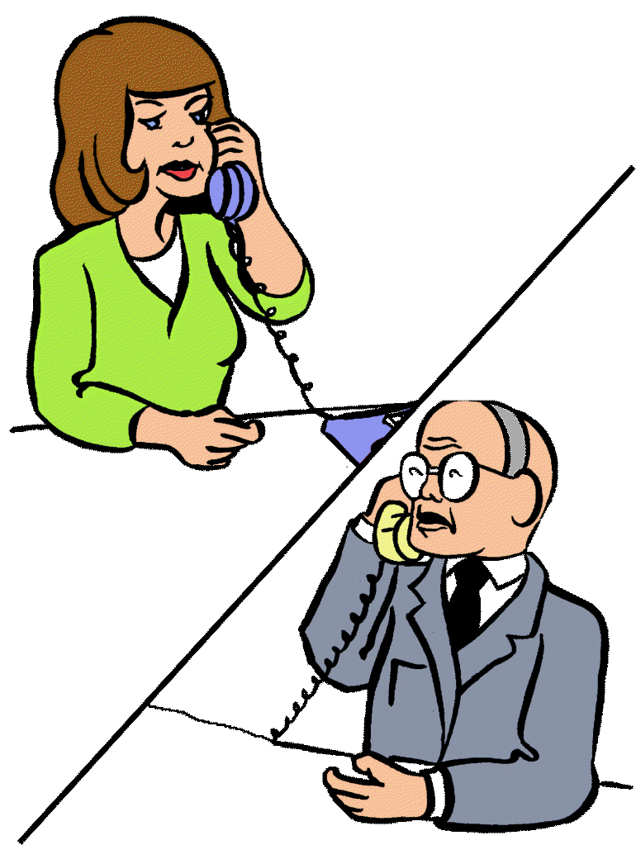 | If we are able to sort out the problem with you over the phone, or by email when we first contact you, we will:
 | Send you an email, or a letter (whichever you prefer) to sum up the conversation you have had, and to confirm the actions that we have taken, or we will take in future.
 | If you are unhappy with this response, you can then make a formal complaint.
 | If it is a more serious complaint, we will investigate the matter as a formal complaint.
 | The formal complaint will be sent to the Chief Executive Officer who will investigate the complaint.
 | The Chief Executive Officer will contact you within 5 working days of the complaint being received, to make sure they understand what the problem has been, and what outcomes you want to achieve by making the complaint.
 | The Chief Executive Officer will confirm this with you in writing, either by email, or post (whichever you prefer).
 | The Chief Executive Office will then investigate the complaint; they can take up to 20 working days to do this.
 | At SOS Hub our working days are Monday – Friday not including any bank holidays, so it can take 3 to 4 weeks to complete an investigation, depending on when the complaint is received.
At the end of the investigation, within the 20 working days, the Chief Executive Officer will:
Send an Email, or letter to you (whichever you prefer) explaining the outcome of the investigation, it will say what they found out and what they decided needs to happen to correct the problem, if anything, and how we will make sure the situation doesn’t happen again, if possible
 | Sometimes the investigation will find that the situation was caused by something that the staff at SOS Hub could not control, in this case the Chief Executive Officer will explain that we could not have done anything differently.
 | If you are still not happy with the outcome, you can choose to make an appeal against the findings, the letter will explain how you can do this.
 | An appeal means that the SOS Hub Trustees will take another 20 working days to do an investigation into the complaint, they will then send you a letter or an email to explain outcome of the investigation, it will say what they found out and whether or not they agree with what the Chief Executive Officer decided.
 | For further information you can contact us on any of the following:
Our Website: www.sosadvocacyhub.org

Email: advocacy@southessexadvocacy.org

Telephone: 01702 340566

Address: Unit 2, 225 to 235 West Road, Westcliff on Sea, Essex, SS0 9DE

Pictures courtesy of CHANGE and Inspired Services

